Cairo University Faculty of Computers and Information



**Software Engineering II**

**Software design specification document**

**2020**

**Project Team**

|  |  |  |  |
| --- | --- | --- | --- |
| **ID** | **Name** | **Email** | **Mobile** |
| 20170043 | Esraa Taha Ali | esraaselim39@gmail.com | 01102790226 |
| 20170044 | Esraa Mohamed | esraamohamed.egy@gmail.com | 01060081977 |
| 20170054 | Afnan Samir Mohamed | afnanetman@gmail.com | 01063750746 |
| 20170202 | Lubna Hassan Atia | lubnahassan35@gmail.com | 01063729033 |

**[Eng Mahmoud Hadad]**

Title page has no header or footer.

Docs must be supplied as pdf –files re-named as requested

Contents

Instructions [To be removed] 2

Class diagram design 2

Sequence diagram design 3

Github repository link 5

# Class diagram design

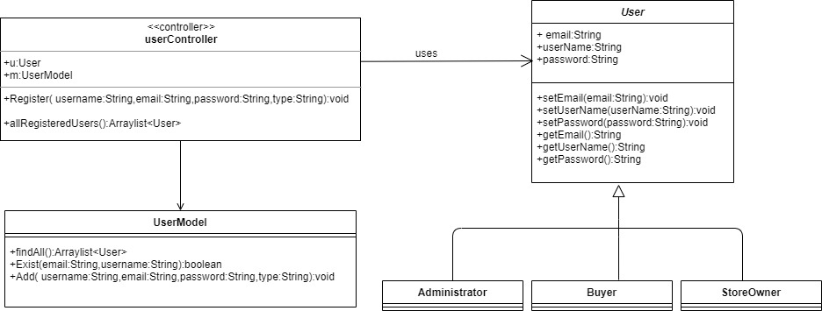

# Sequence diagram design

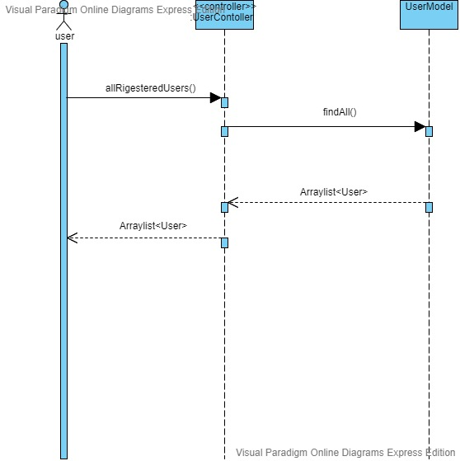

# Github repository link

* **https://github.com/esraa2367/SWE2_PROJECT.git**,